LAB 3: MOVIE INDUSTRY ANALYSIS - STATISTICAL FOUNDATIONS
Toleubek Assiya

PART 1: DATA EXPLORATION & CLEANING
Task 1.1: Initial Exploration
Questions:
- How many movies and columns are in the dataset? 15 columns and 7668 movies
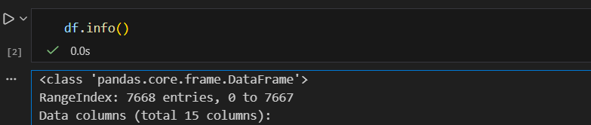
- Which columns have missing data, and how much?
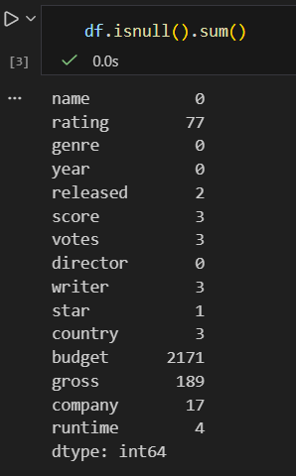
- What are the data types for each column?
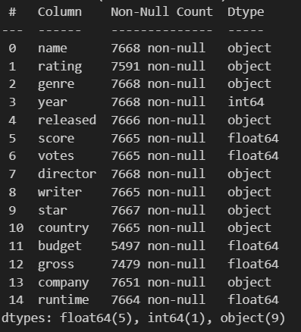
Task 1.2: Handling Missing Data
- For metascore, decide whether to:
a) Remove rows with missing values
b) Fill with median value by genre
c) Fill with median value by release year
- Justify your choice and implement it.
This method was chosen because metascore tend to vary across genres, and genre-based imputation preserves these differences. The median was used instead of the mean since it is more robust to outliers.
Task 1.3: Data Validation
Check for and handle any:
- Impossible values (e.g., negative budget, runtime < 10 minutes)
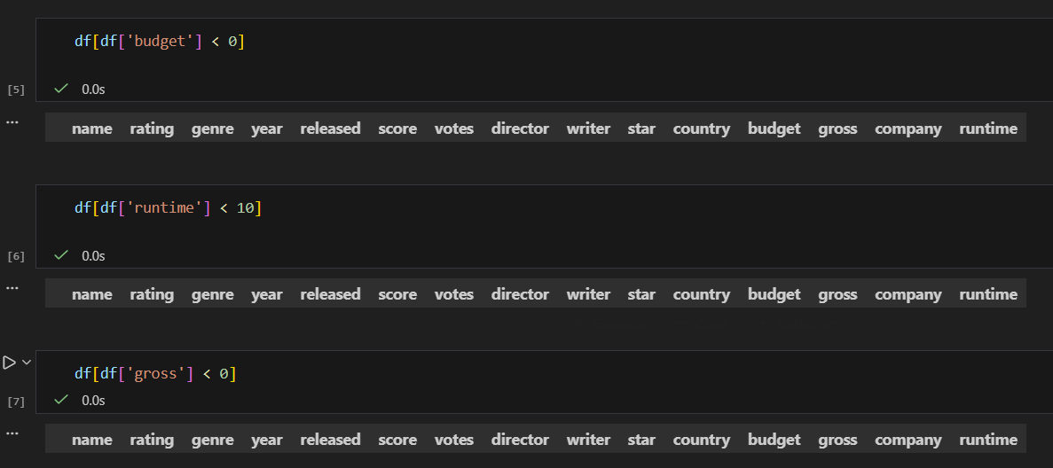
- Extreme outliers (use IQR method to identify)
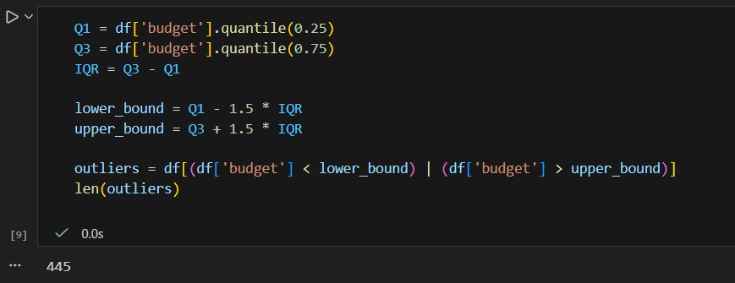
Outliers were identified using the IQR method = 445 outliers, and handled to reduce their impact on analysis
- Inconsistent data (e.g., revenue < budget for profitable movies)

1752 movies have gross revenue lower than budget, reflecting real-world unprofitable films, so these rows were retained

PART 2: DESCRIPTIVE STATISTICS
Task 2.1: Numerical Summary
For EACH numerical column (budget, revenue, runtime, imdb_rating, metascore, votes, oscar_nominations, oscar_wins):
- Calculate: mean, median, mode, range, variance, standard deviation, IQR, 5-number summary
- Create a summary table
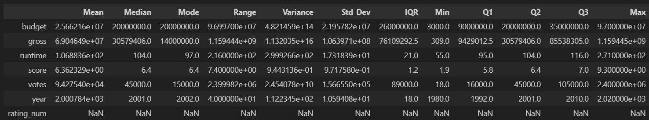

Task 2.2: Categorical Summary
For EACH categorical column (genre, director, main_actor):
- Count unique values


- Show top 10 most frequent values
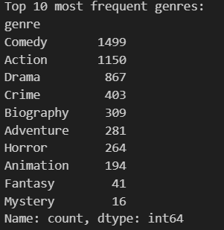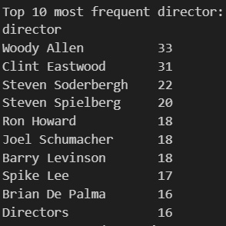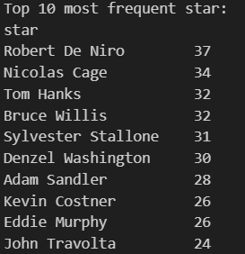
- Calculate proportions/percentages
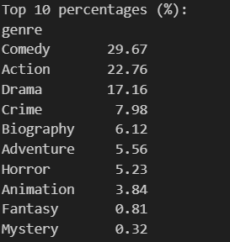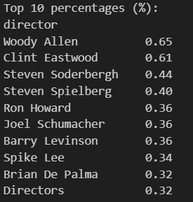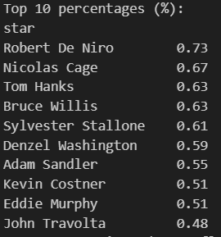
Task 2.3: Statistical Interpretation
Based on your calculations:
- Which numerical variables are most variable (highest coefficient of variation)?
The most variable numerical variables are votes=1.66, gross=1.54, and budget=0.86, indicating that audience votes, revenue, and budgets vary widely across films, while runtime=0.16, score=0.15, and year=0.01 are relatively stable
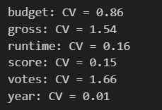
- Which variables are highly skewed? Calculate skewness using: 3*(mean - median)/SD
Variables gross=1.08, votes=0.94, budget=0.77, and runtime=0.50 are moderately right-skewed, indicating that a few movies have extremely high values. In contrast, score=-0.12 and year=-0.06 are roughly symmetric
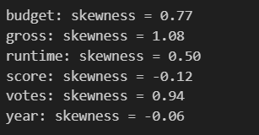
- Identify 3 interesting patterns from the descriptive statistics
1- A few blockbuster films have extremely high budgets (up to $95M) heavily skewing the distributions. This demonstrates that budget is highly variable and right-skewed.
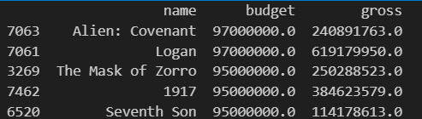
2- Most movies have runtimes between 95–116 minutes. There are a few outliers, but overall movie lengths are fairly consistent.
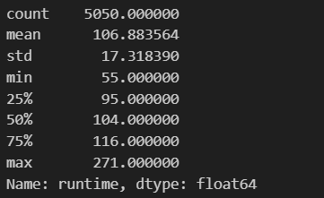

3- IMDb scores mostly cluster around 6–7, with a mean of 6.36 and median of 6.4. There are a few extreme ratings, but most films are rated moderately rather than extremely high or low.
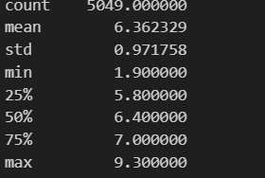

PART 3: DISTRIBUTION ANALYSIS
Task 3.1: Distribution Visualization
Create a 2x4 grid of subplots showing:
- Histogram with density curve for each numerical variable
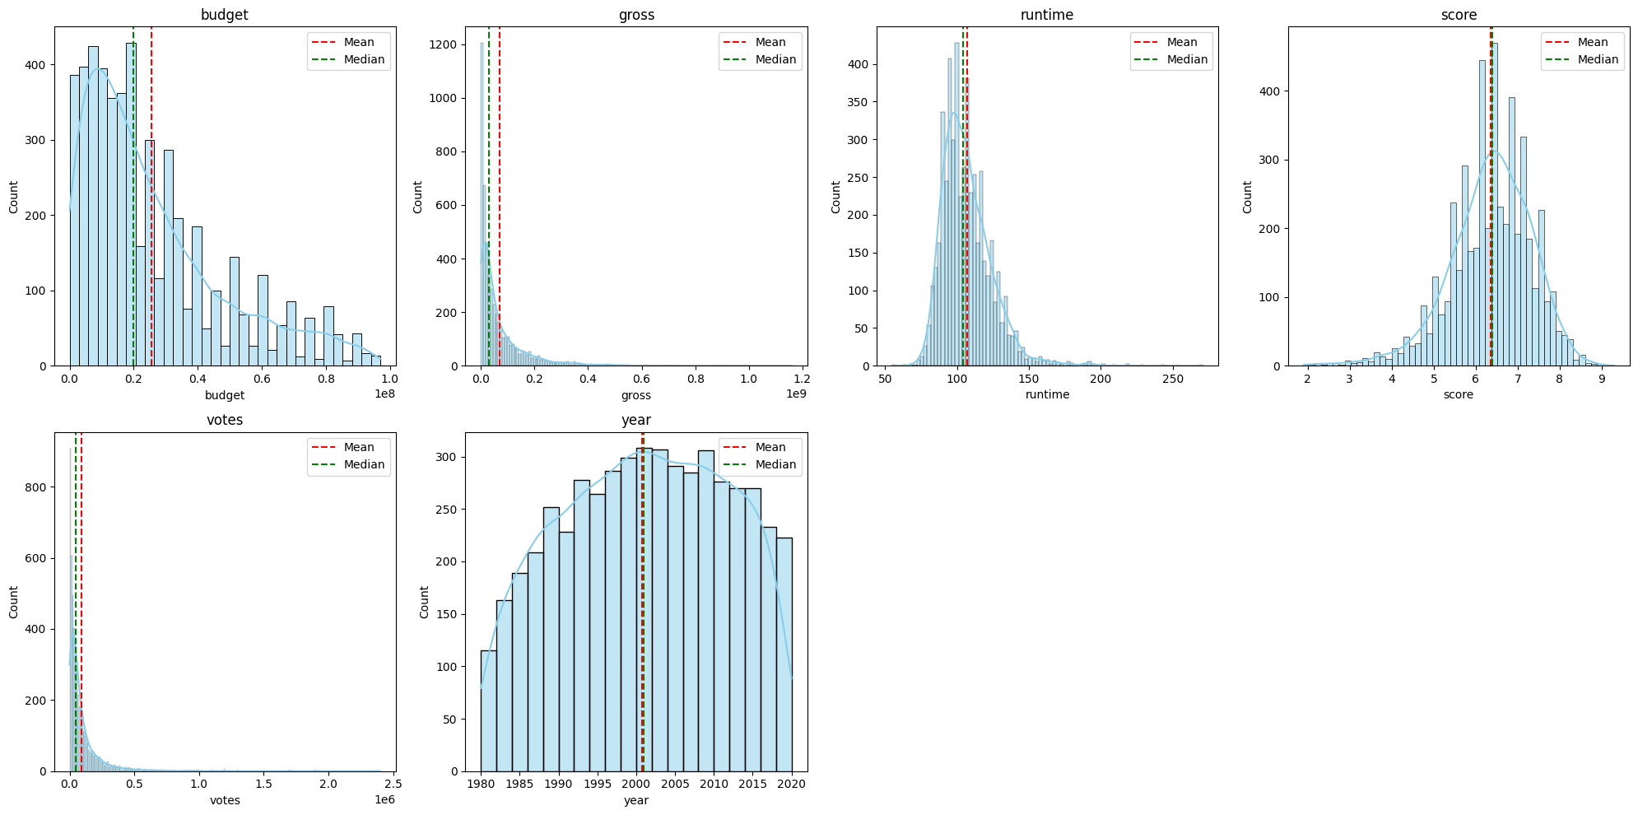
- Box plot for each numerical variable
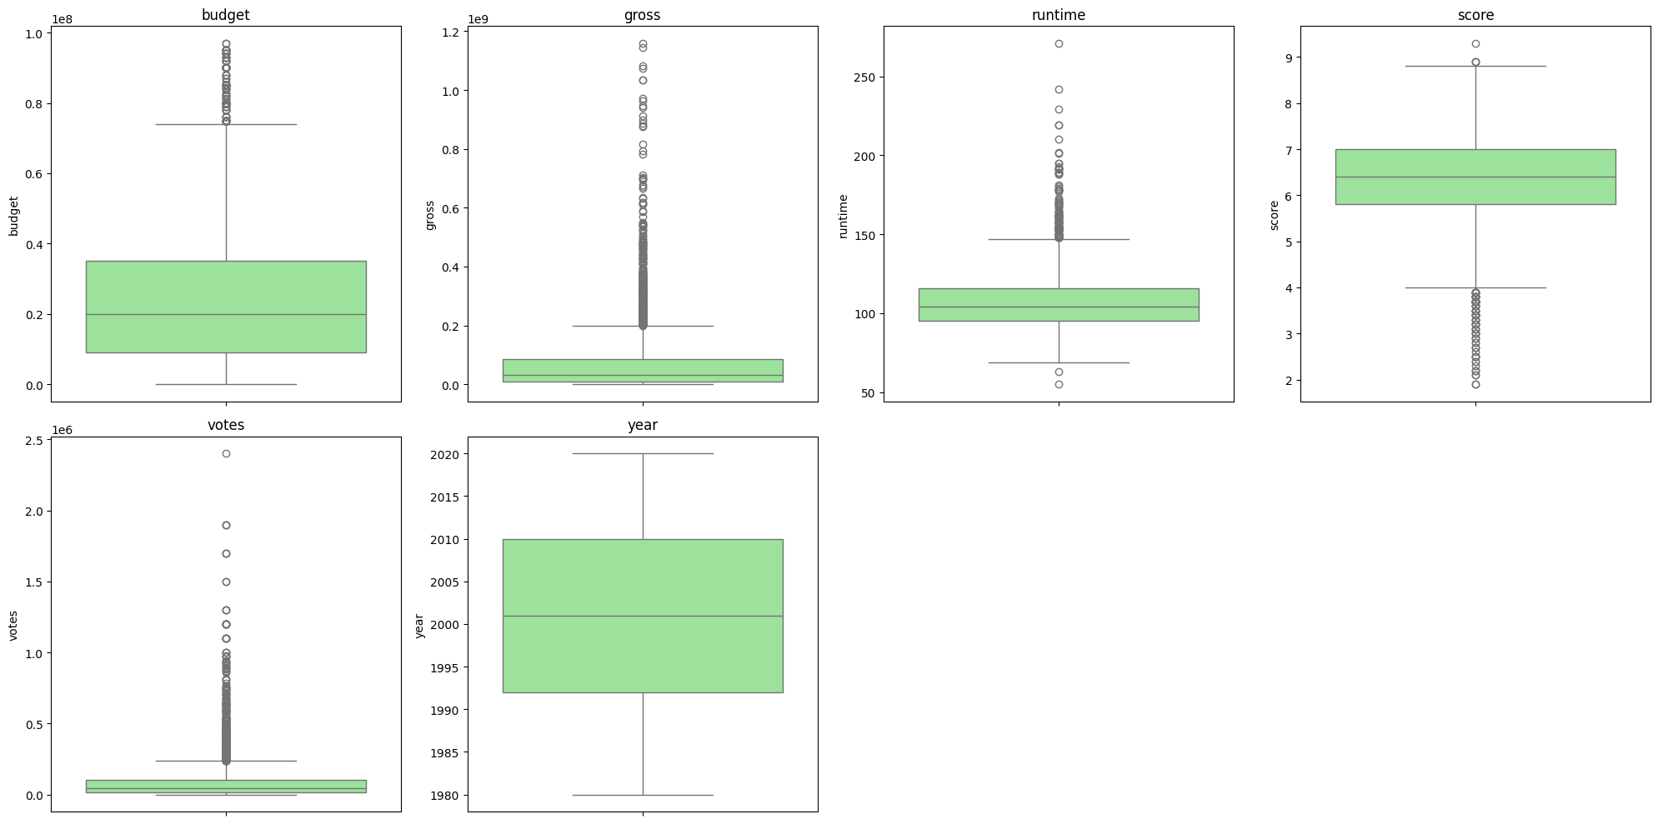
- Add vertical lines for mean (red) and median (green)
Task 3.2: Outlier Analysis
For budget, revenue, and votes:
- Identify outliers using the IQR method (1.5×IQR rule)
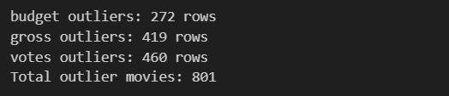
- Create a new DataFrame outliers_df containing all outlier movies
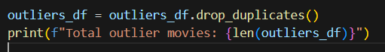

- Analyze: What percentage of total revenue comes from outlier movies?
- Are these outliers errors or genuine extreme cases? Investigate 5 specific outlier movies.
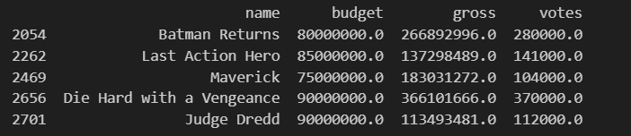
Task 3.3: Normality Assessment
For imdb_rating:
- Create a Q-Q plot to assess normality
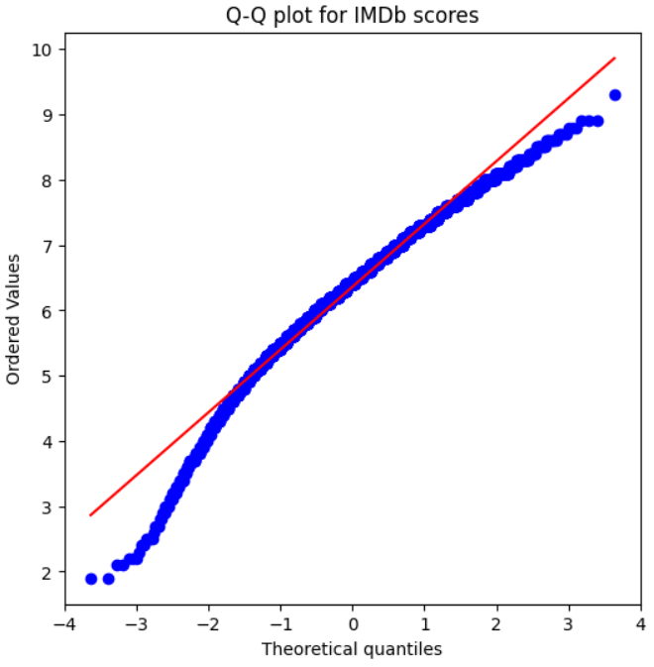
- Calculate how many ratings fall within 1, 2, and 3 standard deviations of the mean
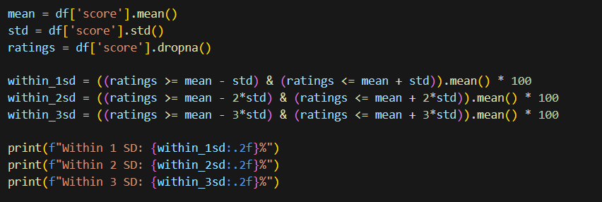
- Compare to the expected 68-95-99.7 rule for normal distributions
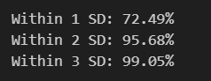
72.49% of ratings are within 1 standard deviation (slightly above 68%), indicating a slightly more complex average.
95.68% and 99.05% of ratings are within 2 and 3 standard deviations, which is almost in line with the expected values ​​according to the 68-95-99.7 rule.
Small deviations in the tails indicate that there are rare extreme ratings (very low or very high).
- Is the distribution approximately normal? Justify.
IMDb ratings are approximately normally distributed. The majority of ratings fall within 1, 2, and 3 standard deviations of the mean, closely following the 68-95-99.7 rule, with minor deviations in the tails.

PART 4: RELATIONSHIP ANALYSIS
Task 4.1: Correlation Analysis
Calculate the correlation matrix for all numerical variables.
python
corr_matrix = df[numerical_cols].corr()
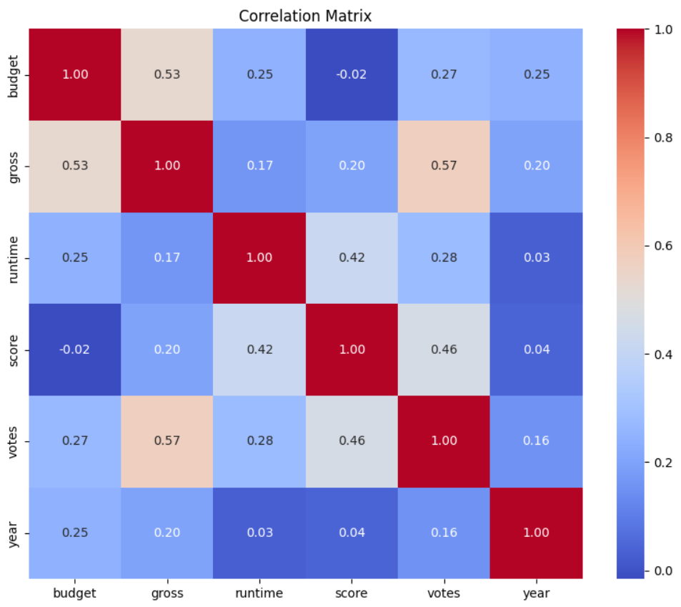
Questions:
- Which pairs have the strongest positive correlation? (> 0.7)
No pairs of numerical variables have a very strong positive correlation (>0.7). Votes and gross have moderate correlation = 0.57
- Which pairs have the strongest negative correlation? (< -0.3)
None (<-0.3), but score and budget have a very weak negative correlation (-0.016)
- Which correlation surprises you? Investigate further.
there is a moderate positive correlation between runtime and score 0.42, suggesting that longer movies tend to receive slightly higher ratings
Task 4.2: Scatter Plot Matrix
Create a scatter plot matrix for: budget, revenue, imdb_rating, votes
- Use different colors for different genres
- Add trend lines
- Make figure size 12x10 inches
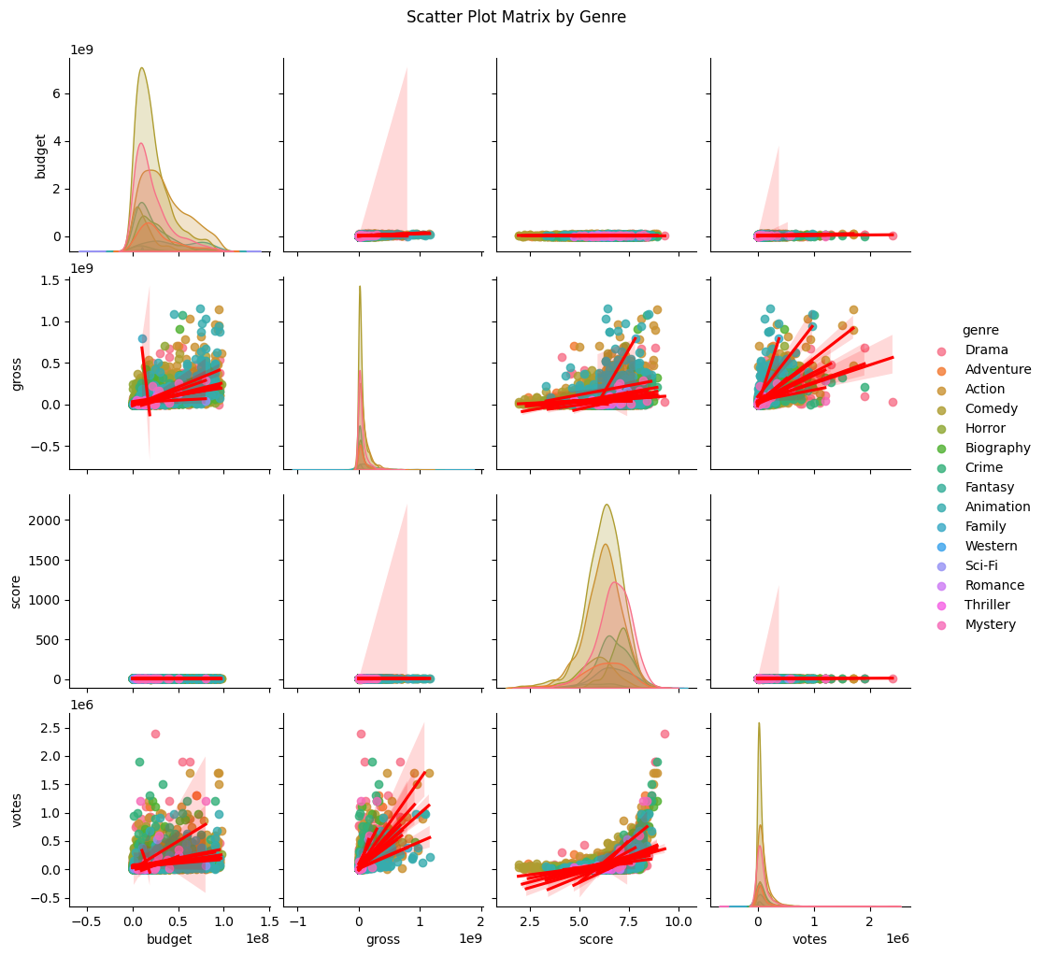
Budget and gross are moderately positively correlated.Score and budget show almost no correlation, confirming that higher budgets do not guarantee better ratings.Votes tend to increase with both gross and score.

Task 4.3: Advanced Relationship Analysis
- Create a new variable profit_margin = (revenue - budget) / budget
  - Handle division by zero (budget = 0)
  - What does infinite profit margin mean? How will you handle it?
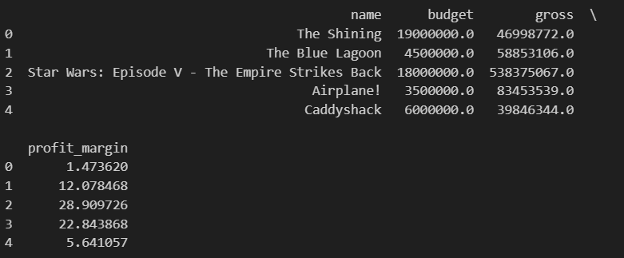
Infinite profit margin occurs when budget = 0
np.where() handles the division by zero
- Calculate correlation between profit_margin and imdb_rating
  - Is there a relationship?
Correlation between profit margin and IMDb score: 0.004376 (almost 0 linear relationship between profit and rating)
  - Create a scatter plot with appropriate transformations if needed
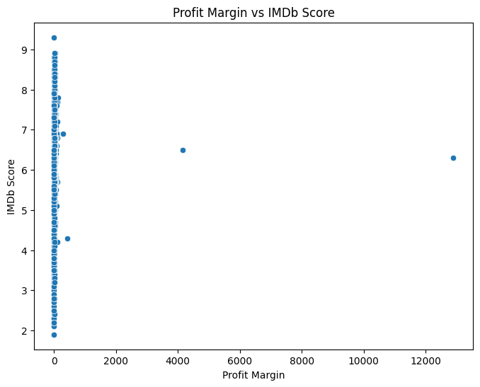
PART 5: COMPARATIVE ANALYSIS
Task 5.1: Genre Comparison
Compare movies across genres for:
- Budget and Revenue: Create side-by-side box plots
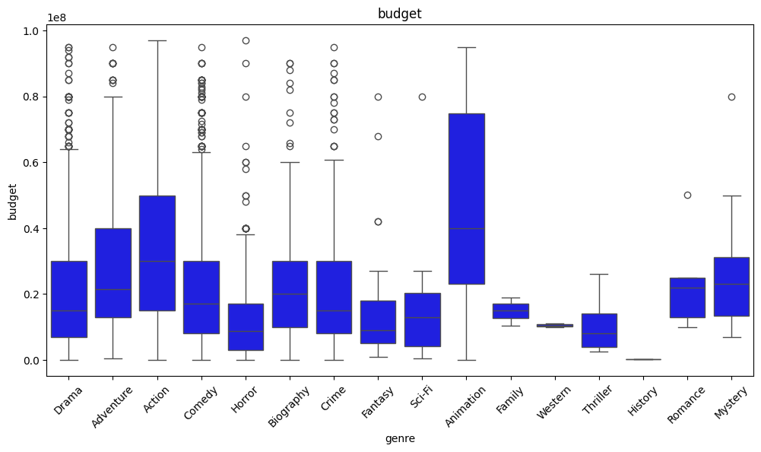
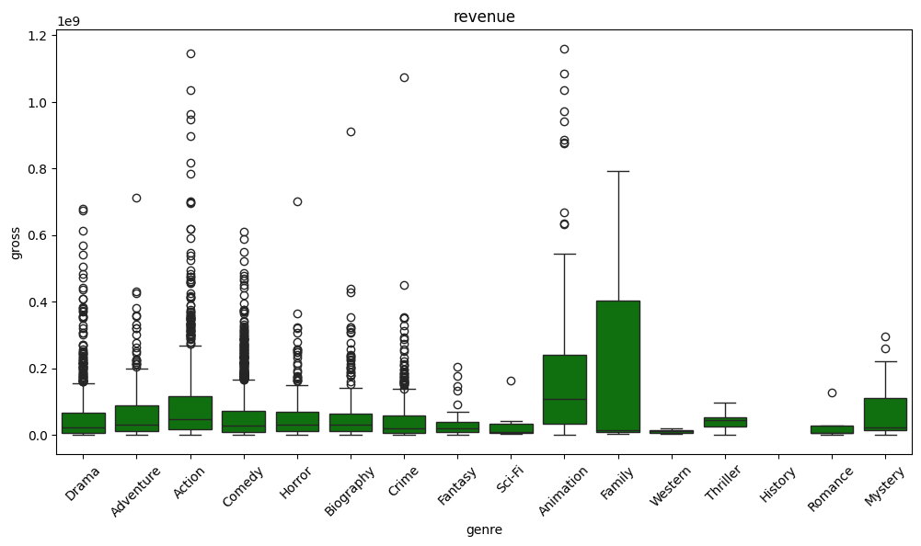

- IMDb Rating: Create violin plots showing distribution shape
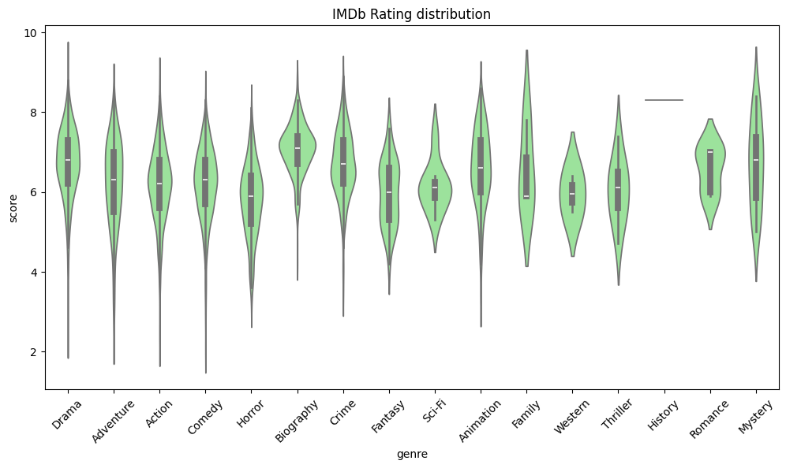
- Profitability: Calculate average profit_margin by genre
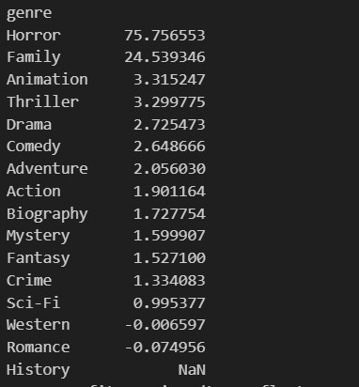

- Awards: Total oscar_wins by genre (profit by genre)
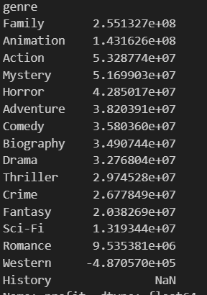
Questions:
- Which genre has the highest median budget? Animation (~0.4)
- Which genre has the most consistent ratings (lowest SD)? Romance (0.576)

- Is there a genre that consistently overperforms (high profit margin relative to budget)? Horror (75.76)

Task 5.2: Time Trend Analysis
- Create a line plot showing average budget by release_year (use 3-year moving average)
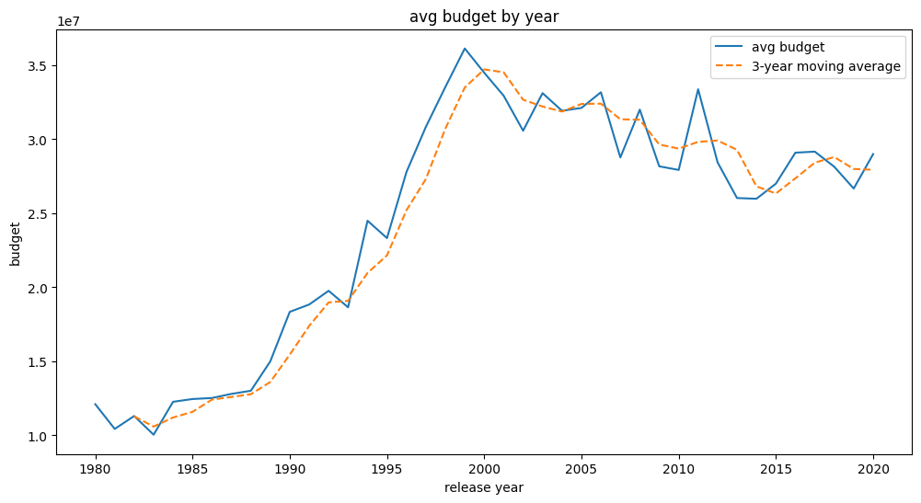

- Create a line plot showing average imdb_rating by release_year
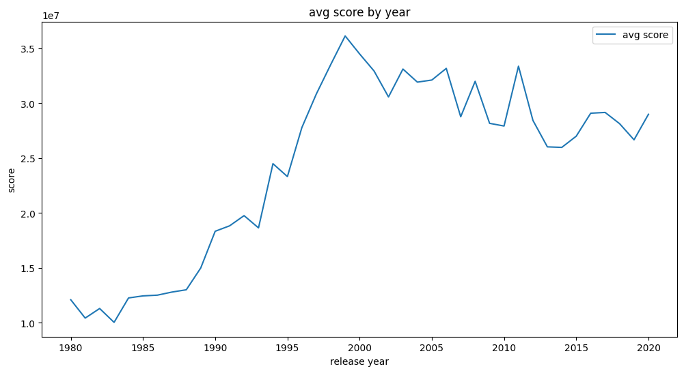
- Has movie quality changed over time? Support your answer with statistics.
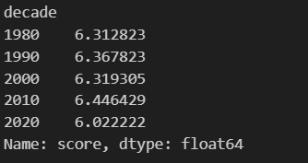
Movie budgets have grown over time, but audience ratings have remained relatively consistent.

Task 5.3: Director Analysis
- Identify top 10 directors by number of movies in dataset
The most prolific directors are: Woody Allen (33), Clint Eastwood (31), Steven Soderbergh (22), Steven Spielberg (20)
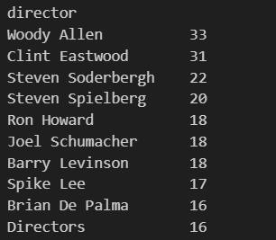

- For these directors, calculate their average:
  - IMDb rating
  - Profit margin
  - Oscar nominations per movie
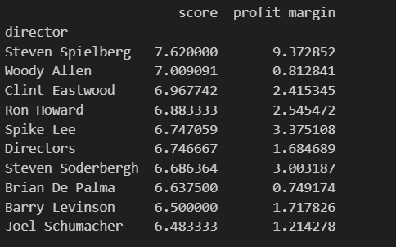
Steven Spielberg stands out with the highest average IMDb score and very high profit margins, confirming his films are both critically acclaimed and commercially successful.
Woody Allen has high IMDb scores but lower profit margins, showing strong critical reception but smaller commercial impact.

